Name: SHASIDHAR R
REG NO: 192524276
Course:DSA0602-Data handling and visuilization

EXPERIMENT 1: Monthly Sales Analysis

library(ggplot2)
library(plotly)

sales <- data.frame(
Month = c("Jan", "Feb", "Mar", "Apr", "May"),
Sales = c(1200, 1500, 1800, 1600, 2000)
)

print(sales)

ggplot(sales, aes(x = Month, y = Sales, group = 1)) +
geom_line(color = "blue", linewidth = 1.2) +
geom_point(color = "red", size = 3) +
labs(
title = "Monthly Sales Trend",
x = "Month",
y = "Sales"
) +
theme_minimal()

ggplot(sales, aes(x = Month, y = Sales, fill = Month)) +
geom_bar(stat = "identity") +
labs(
title = "Monthly Sales Comparison",
x = "Month",
y = "Sales"
) +
theme_minimal()

ggplot(sales, aes(x = Month, y = Sales)) +
geom_point(size = 4, color = "blue") +
geom_smooth(aes(group = 1), method = "lm", se = FALSE, color = "red") +
labs(
title = "Monthly Sales Scatter Plot",
x = "Month",
y = "Sales"
) +
theme_minimal()

p1 <- plot_ly(
sales,
x = ~Month,
y = ~Sales,
type = "scatter",
mode = "lines+markers"
)

p2 <- plot_ly(
sales,
x = ~Month,
y = ~Sales,
type = "bar"
)

subplot(p1, p2, nrows = 2)
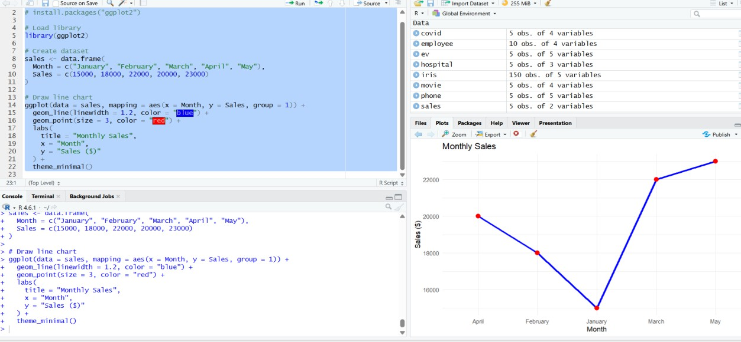

EXPERIMENT 2: Customer Feedback Analysis

PROGRAM

library(ggplot2)

library(wordcloud)

library(RColorBrewer)

customer <- data.frame(

Age = c(20, 25, 30, 35, 40),

Satisfaction = c("High", "Medium", "High", "Low", "Medium")

)

print(customer)

ggplot(customer, aes(x = Age)) +

geom_histogram(binwidth = 5, fill = "skyblue", color = "black") +

labs(

title = "Customer Age Distribution",

x = "Age",

y = "Frequency"

) +

theme_minimal()

pie(

table(customer$Satisfaction),

col = rainbow(3),

main = "Customer Satisfaction Level"

)

customer$Age_Group <- c("20-25", "20-25", "30-35", "30-35", "40+")

ggplot(customer, aes(x = Age_Group, fill = Satisfaction)) +

geom_bar() +

labs(

title = "Satisfaction by Age Group",

x = "Age Group",

y = "Count"

) +

theme_minimal()

wordcloud(

words = customer$Satisfaction,

freq = c(2, 2, 1, 1, 2),

colors = brewer.pal(8, "Dark2")

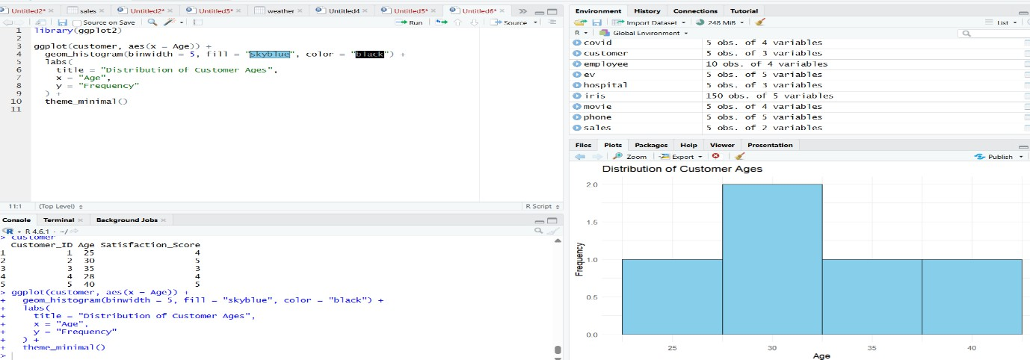

EXPERIMENT 3: Employee Performance Analysis

library(ggplot2)

library(plotly)

employee <- data.frame(

Employee_ID = c(1, 2, 3, 4, 5),

Department = c("Sales", "HR", "Marketing", "Sales", "HR"),

Years_of_Service = c(5, 3, 7, 4, 2),

Performance_Score = c(85, 92, 78, 90, 76)

)

print(employee)

ggplot(employee, aes(x = Years_of_Service, y = Performance_Score, group = 1)) +

geom_line(color = "blue", linewidth = 1.2) +

geom_point(color = "red", size = 3) +

labs(

title = "Employee Performance Trend",

x = "Years of Service",

y = "Performance Score"

) +

theme_minimal()

ggplot(employee, aes(x = Department, fill = Department)) +

geom_bar() +

labs(

title = "Employees by Department",

x = "Department",

y = "Number of Employees"

) +

theme_minimal()

ggplot(employee, aes(x = Years_of_Service, y = Performance_Score)) +

geom_point(size = 4, color = "blue") +

geom_smooth(method = "lm", se = FALSE, color = "red") +

labs(

title = "Years of Service vs Performance",

x = "Years of Service",

y = "Performance Score"

) +

theme_minimal()

p1 <- plot_ly(

employee,

x = ~Years_of_Service,

y = ~Performance_Score,

type = "scatter",

mode = "lines+markers"

)

p2 <- plot_ly(

employee,

x = ~Department,

type = "bar"

)

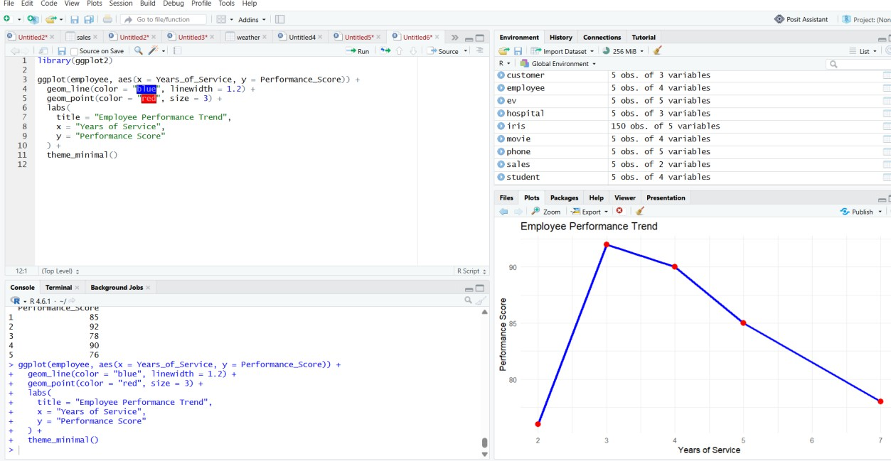

EXPERIMENT 4: Product Inventory Analysis

PROGRAM
library(ggplot2)
library(plotly)

inventory <- data.frame(
Product_Name = c("Product A", "Product B", "Product C", "Product D", "Product E"),
Category = c("Electronics", "Electronics", "Furniture", "Furniture", "Furniture"),
Price = c(500, 650, 450, 700, 550),
Quantity = c(250, 175, 300, 200, 220)
)

print(inventory)

ggplot(inventory, aes(x = Product_Name, y = Quantity, fill = Product_Name)) +
geom_bar(stat = "identity") +
labs(
title = "Product Inventory",
x = "Product Name",
y = "Quantity"
) +
theme_minimal()

ggplot(inventory, aes(x = Category, y = Quantity, fill = Product_Name)) +
geom_bar(stat = "identity") +
labs(
title = "Inventory by Category",
x = "Category",
y = "Quantity"
) +
theme_minimal()

ggplot(inventory, aes(x = Price, y = Quantity)) +
geom_point(size = 4, color = "blue") +
geom_smooth(method = "lm", se = FALSE, color = "red") +
labs(
title = "Price vs Quantity",
x = "Price",
y = "Quantity"
) +
theme_minimal()

p1 <- plot_ly(
inventory,
x = ~Product_Name,
y = ~Quantity,
type = "bar"
)

p2 <- plot_ly(
inventory,
x = ~Price,
y = ~Quantity,
type = "scatter",
mode = "markers"
)

subplot(p1, p2, nrows = 2) 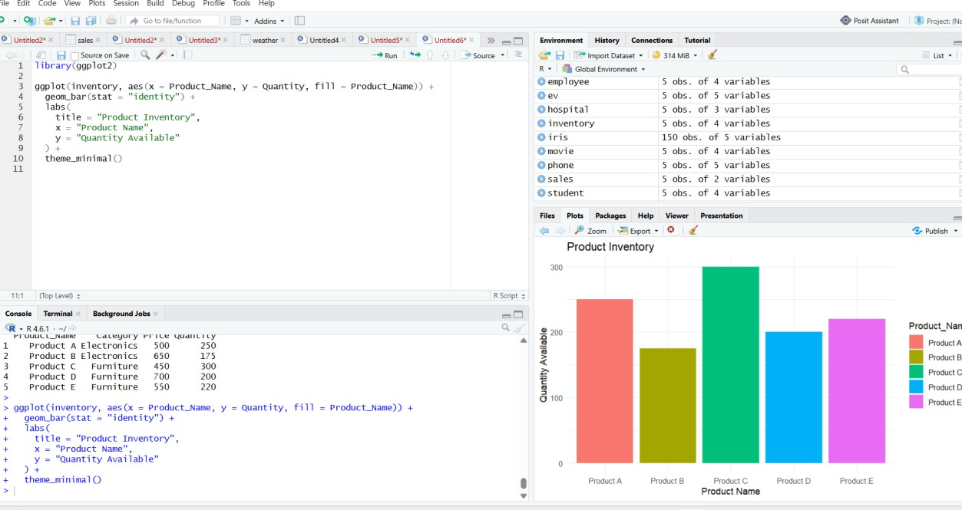

SET 5: Website Analytics

library(ggplot2)
library(plotly)
library(tidyr)

traffic <- data.frame(
Date = as.Date(c(
"2023-01-01",
"2023-01-02",
"2023-01-03",
"2023-01-04",
"2023-01-05"
)),
Page_Views = c(
1500,
1600,
1400,
1650,
1800
),
CTR = c(
2.3,
2.7,
2.0,
2.4,
2.6
)
)

print(traffic)

ggplot(traffic, aes(x = Date, y = Page_Views, group = 1)) +
geom_line(color = "blue", linewidth = 1.2) +
geom_point(color = "red", size = 3) +
labs(
title = "Daily Website Page Views",
x = "Date",
y = "Page Views"
) +
theme_minimal()
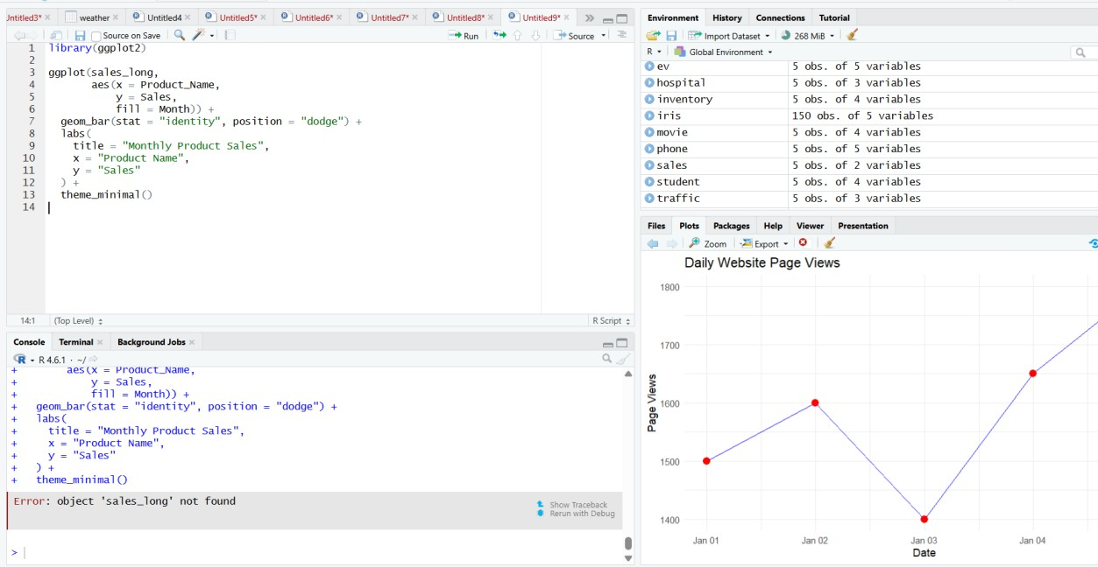

Set 6-Product Sales Analysis
- Create a grouped bar chart to visualize the sales of each product for the first quarter. Label the chart elements.

library(ggplot2)

library(tidyr)

sales <- data.frame(

Product_ID = c(1, 2, 3),

Product_Name = c("Product A", "Product B", "Product C"),

January = c(2000, 1500, 1200),

February = c(2200, 1800, 1400),

March = c(2400, 1600, 1100)

)

sales_long <- pivot_longer(

sales,

cols = c(January, February, March),

names_to = "Month",

values_to = "Sales"

)

ggplot(sales_long, aes(x = Product_Name, y = Sales, fill = Month)) +

geom_bar(stat = "identity", position = "dodge") +

labs(

title = "First Quarter Product Sales",

x = "Product",

y = "Sales"

) +

theme_minimal()Output:

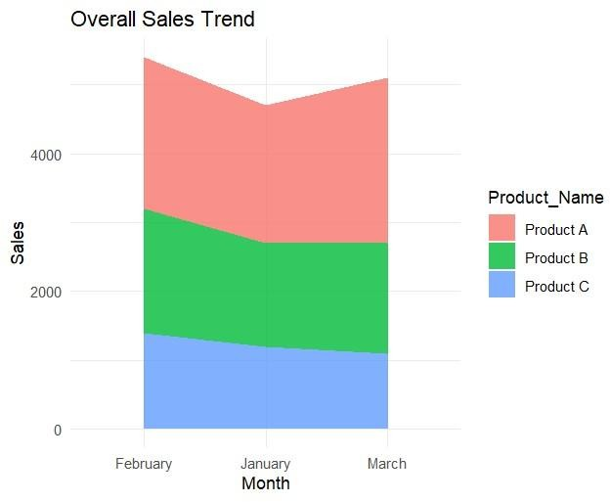

- Generate a stacked area chart to represent the overall sales trend for all products over the three months.

library(ggplot2)

library(tidyr)

sales <- data.frame(

Product_Name = c("Product A", "Product B", "Product C"),

January = c(2000, 1500, 1200),

February = c(2200, 1800, 1400),

March = c(2400, 1600, 1100)

)

sales_long <- pivot_longer(

sales,

cols = c(January, February, March),

names_to = "Month",

values_to = "Sales"

)

sales_long$Month <- factor(

sales_long$Month,

levels = c("January", "February", "March")

)

ggplot(sales_long, aes(x = Month, y = Sales, fill = Product_Name, group = Product_Name)) +

geom_area(alpha = 0.8) +

labs(

title = "Overall Sales Trend",

x = "Month",

y = "Sales"

) +

theme_minimal()

Output:

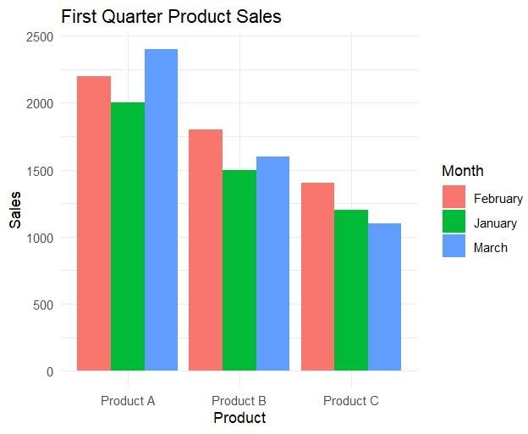

- Build a table to show the monthly sales data for each product. Label the table elements.
sales <- data.frame(
Product_ID = c(1, 2, 3),
Product_Name = c("Product A", "Product B", "Product C"),
January_Sales = c(2000, 1500, 1200),
February_Sales = c(2200, 1800, 1400),
March_Sales = c(2400, 1600, 1100)
)

print(sales)) Output:
Product_Name January February March

1 Product A | 2000 | 2200 | 2400
2 Product B | 1500 | 1800 | 1600
3 Product C | 1200 | 1400 | 1100

